ack side. Idfps. One the dl 3**Ban han part report**

**Desktop Version development and GUI( Han BAO) (551)**

**(the key findings about these topics and how to apply them into our project)**

In this semester, our group focus much more on desktop version. We use Eclipse as tool and use Java language with limited knowledge and limited time. Swing and Awt packages in Java constitute the whole GUI for desktop part. Desktop version GUI mainly has four parts, menu, chessboard, buttons and history list, as showing in 4.2.1.1.

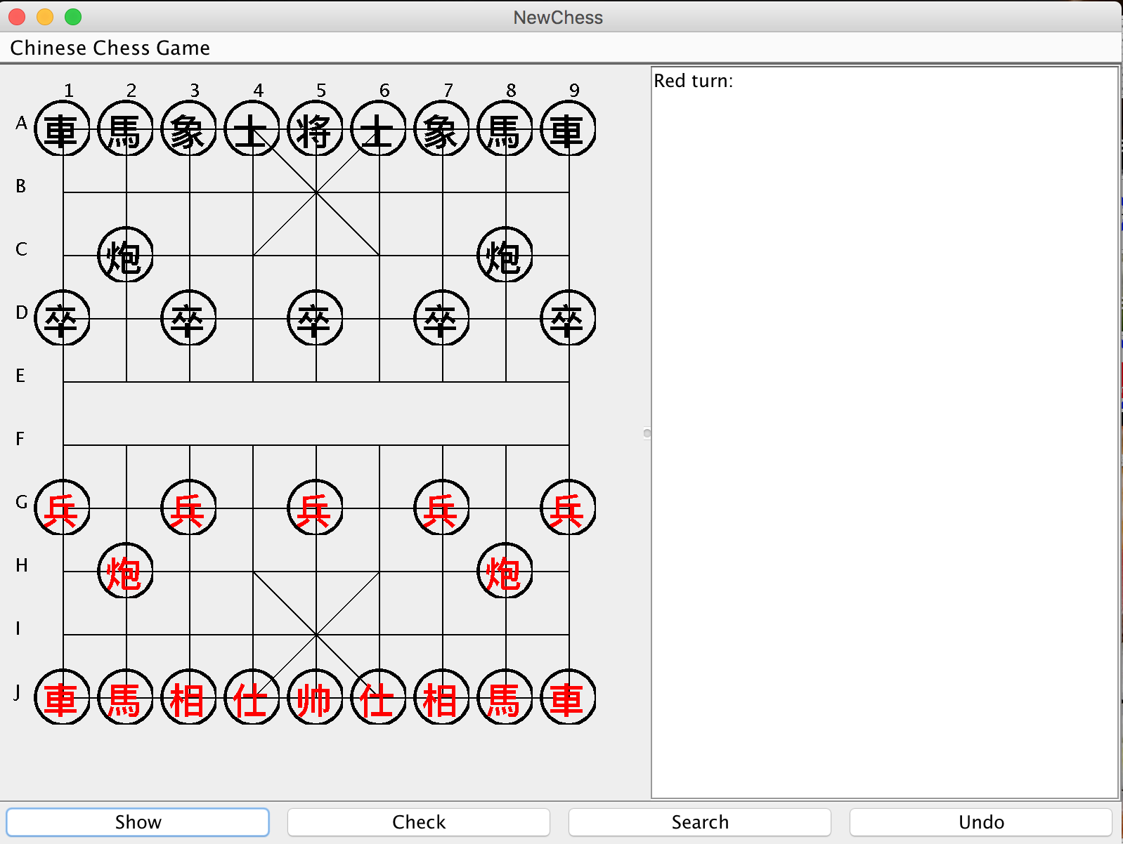

4.2.1.1

* Menu: Only has a restart function.
* Chessboard (figure 4.2.1.2): After a lot of research, most chessboard uses numbers or alphabets(Bodlaender, H. and Duniho, F., 2014). Some prefer to lowercase letters and some prefer uppercase letter.Use ‘A’ to ‘J’ and ‘1’ to ‘9’ to give a certain and clear point in the board when the history points are listed.A game of Anvanced Xiangqi has two sides, one is black and one is red. As the rule shows, red goes first and user could choose any side. If user moves piece invalid or chooses wrong side, there is an alert window and then give a warning on it. When we click one piece, the color will change to blue to tell users that they have got a clicked piece .

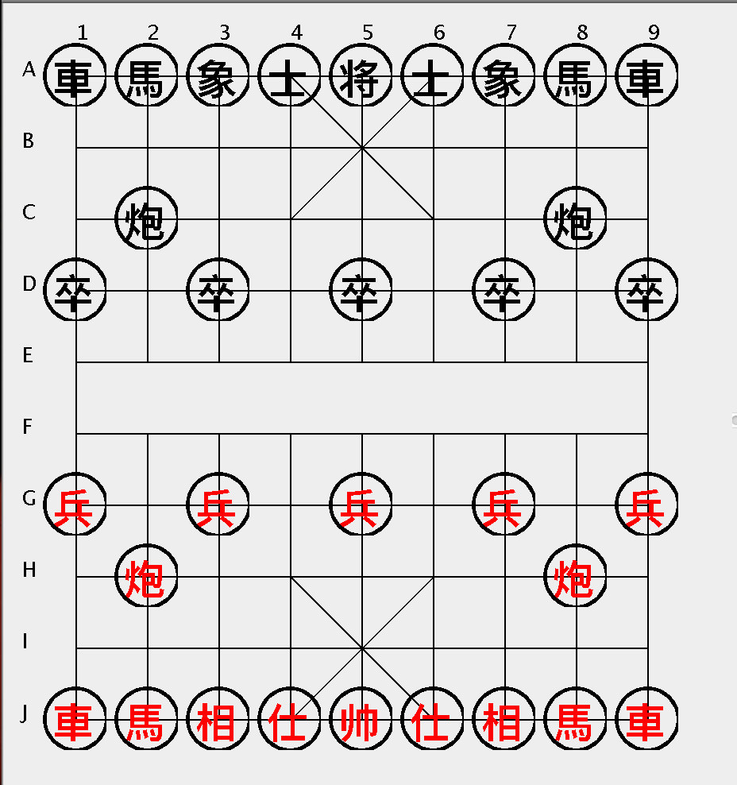

4.2.1.2

* Buttons: There are four functional buttons.



means that check the last step is necessary and give a judgement of tempoary situation.

means that it gives the next step advice from the temporary chessboard situation.

means that it delete the last move step in the history and move this piece back.

All results would show in the history board.

* History board: Remind user which color turns and shows the move step and give some notice. In addition, results of the functional buttons are showing in the history part.

**（這裡可以取個什麼名字）**

To explain better, we play a game of Advanced Xiangqi on this program.

Example:

1. Suppose that red is our side, showing in figure 4.2.1.3.
2. Move red piece “馬”, from “J2” to “H3” showing in figure 4.2.1.4.
3. Move black piece “炮”, from “C8” to “C5” showing in figure 4.2.1.5.
4. User does not how to play next, so he clicks “Search”, it gives serveral answers( genernal three answers) showing in figure 4.2.1.6.
5. User also wants to guess the following steps, so he clicks “Show”, it also gives three steps. Two are red side and one is black side. If there are some dangerous signals such as losing pieces or game, user can see them in advance, showing in 4.2.1.7.
6. According to the “Show” and “Search” result, user wants use none of them. User chooses a piece is Red “炮”, click “Check” and get a result of possibilities, showing in 4.2.1.8.
7. Also, user can click “Undo” to cancel this step.

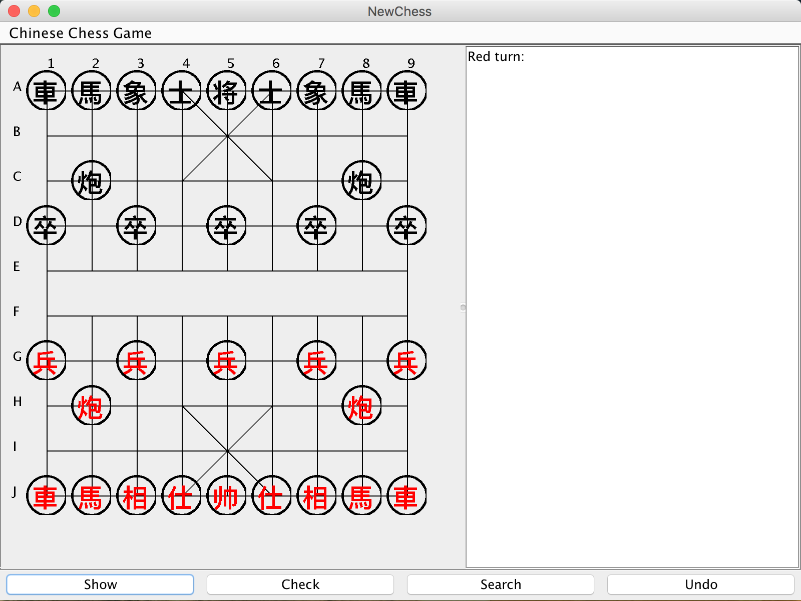 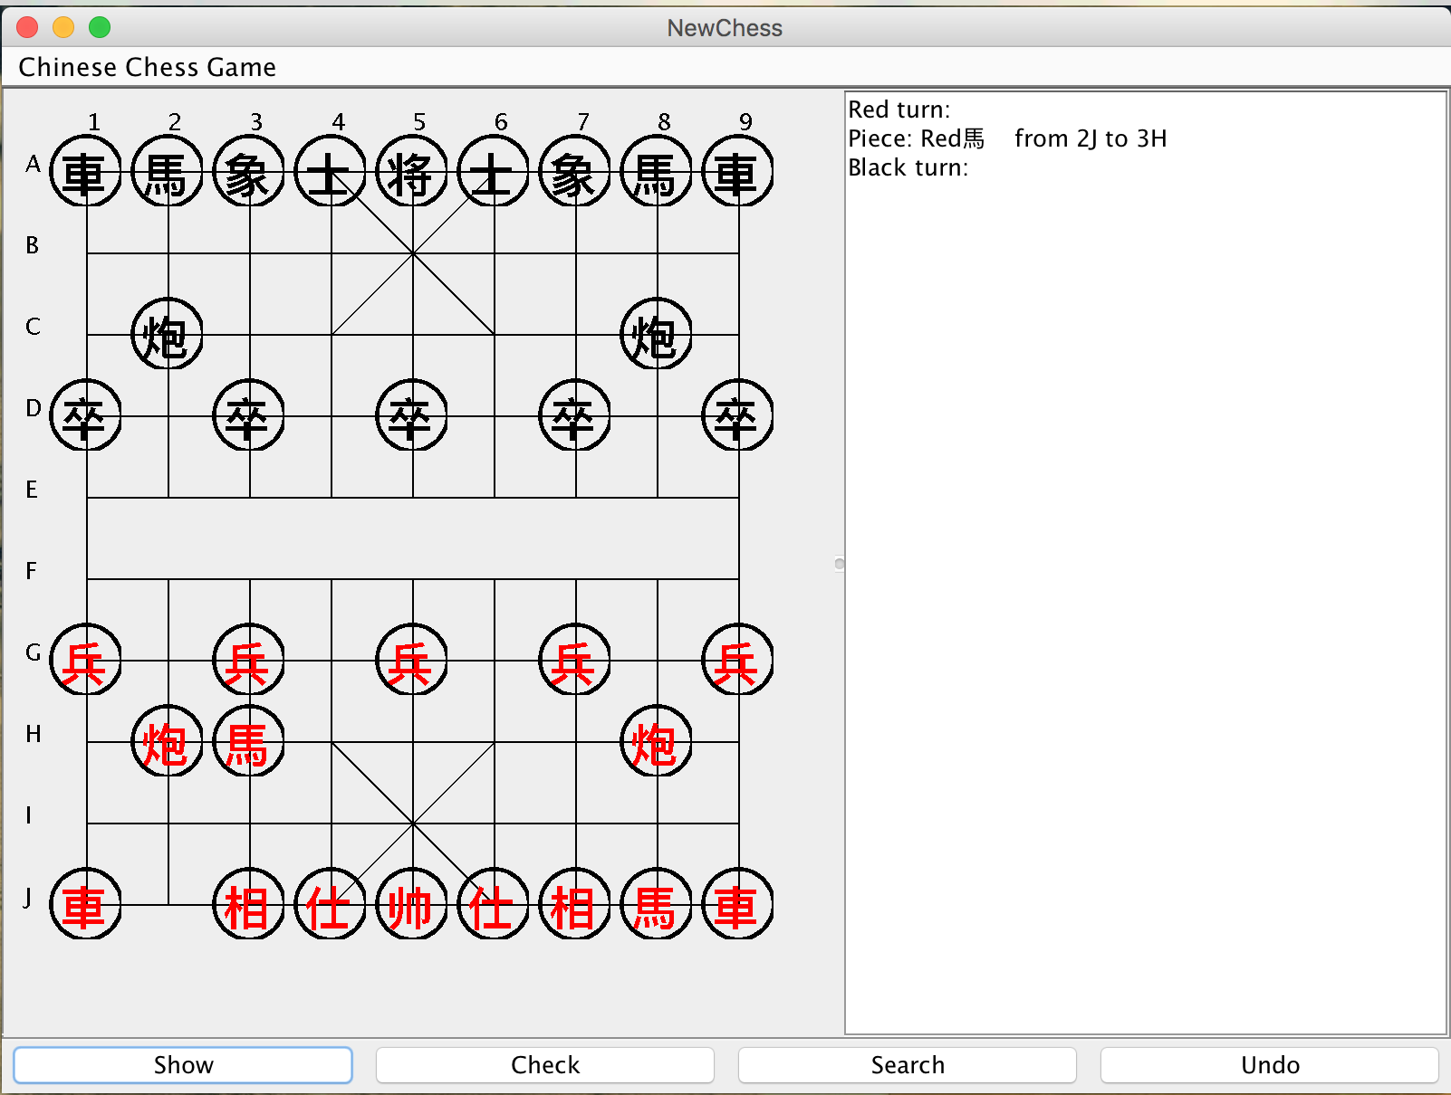

figure 4.2.1.3 figure 4.2.1.4

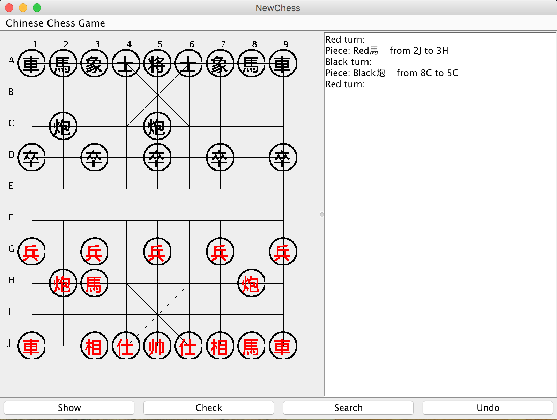 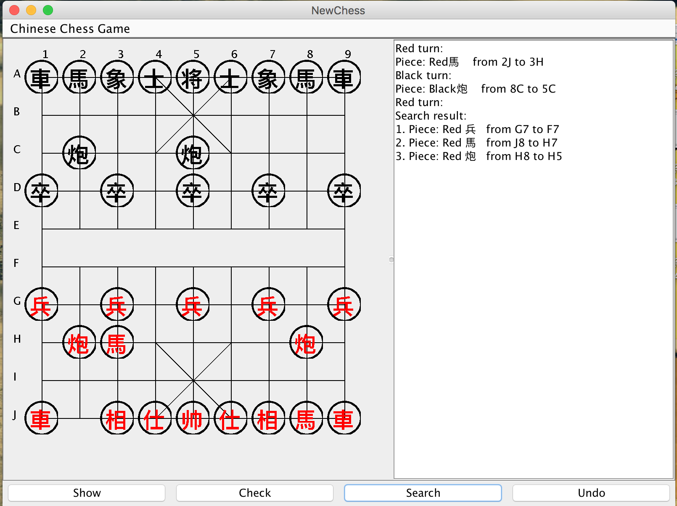

figure 4.2.1.5 figure 4.2.1.6

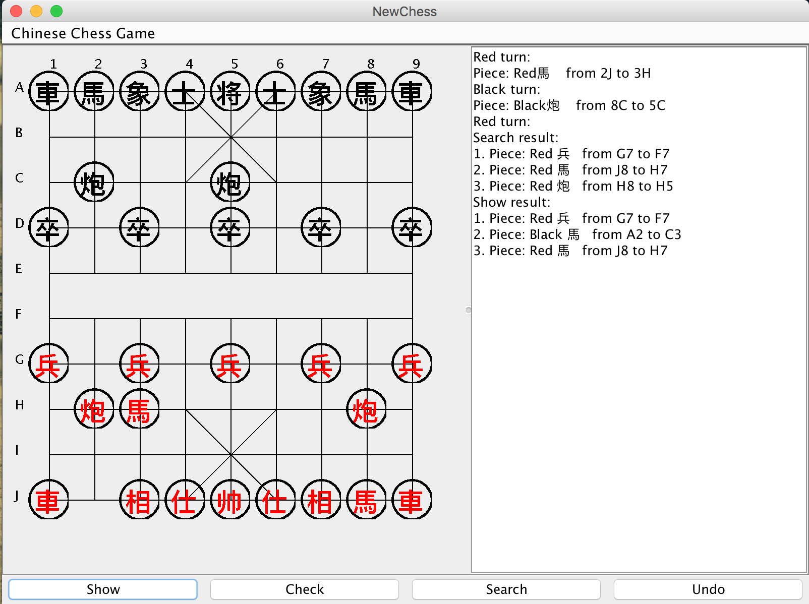 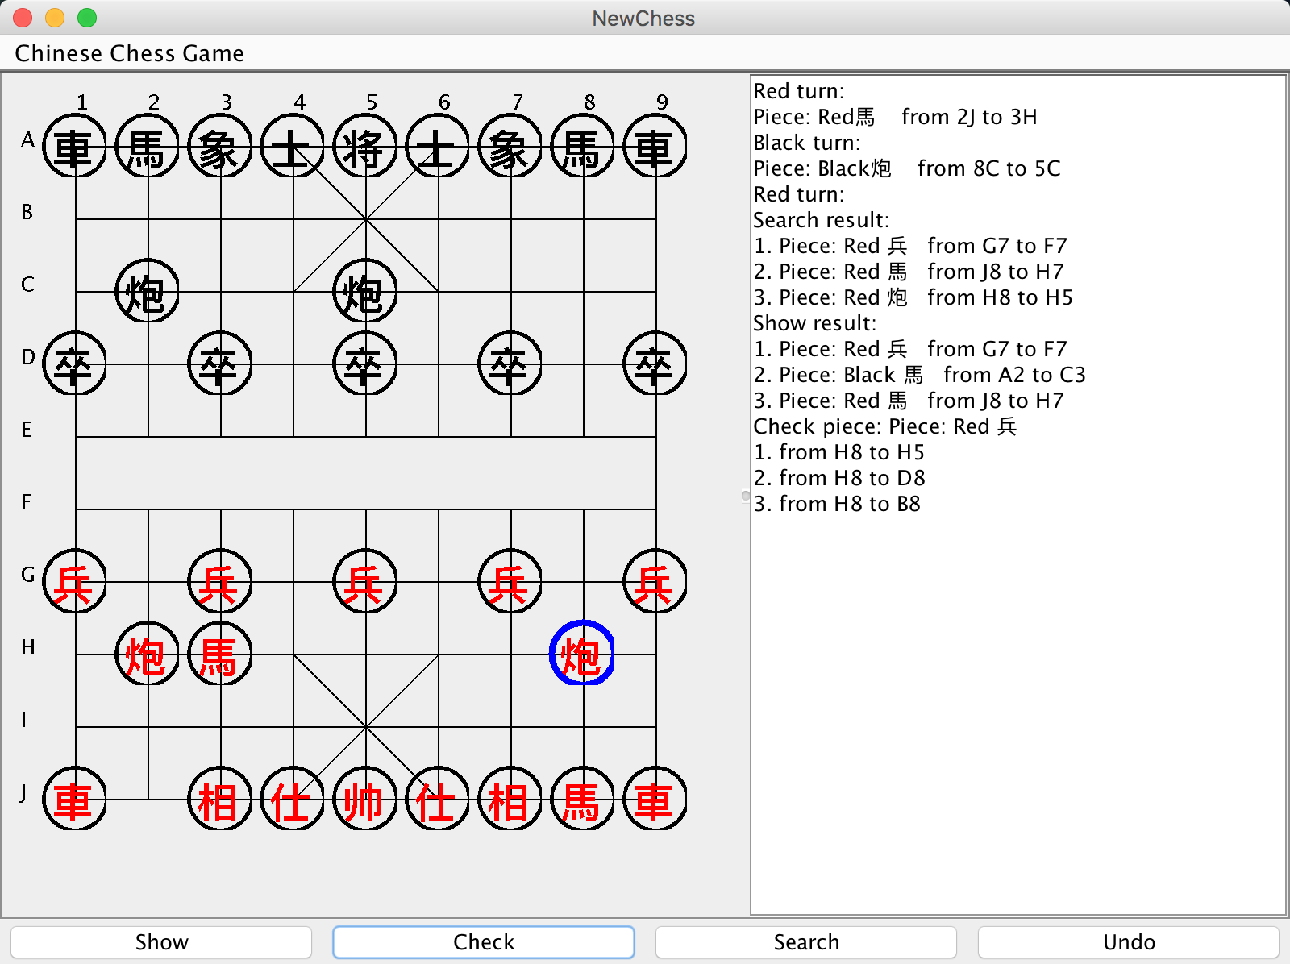

figure 4.2.1.7 figure 4.2.1.8

Warnings:

Because some inevitable mistakes, users would get alert warning.

* Figure 4.2.1.9 means that user click empty point when user turns on.
* Figure 4.2.1.10 shows invalid move warning.
* Figure 4.2.1.11 also warns one situation of the invalid move.
* Figure 4.2.1.12 shows the end of this game because of the victory of one side.

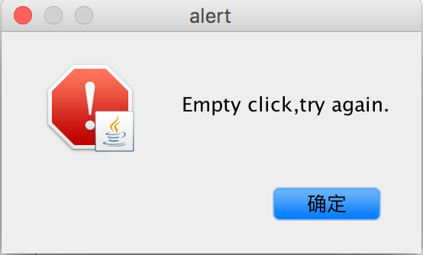 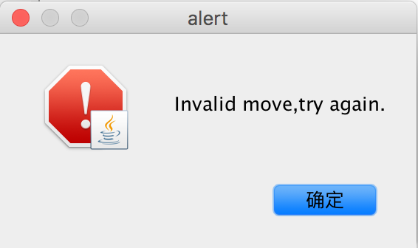

figure 4.2.1.9 figure 4.2.1.10

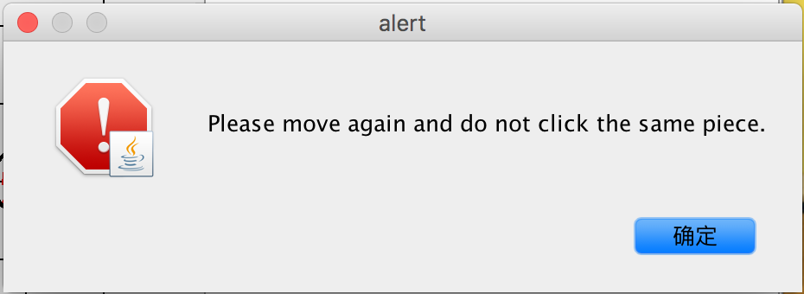 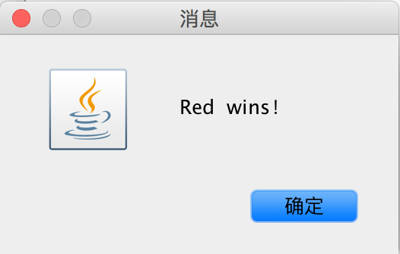

figure 4.2.1.11 figure 4.2.1.12

**Time plan (195)**

Up to now, our group has finished most work as this plan. In the first month, research is the mainly work. Then we embarked on desktop version. During the whole semester, our group had regular formal meetings and weekly informal meetings. We appreciate deeply that the supervisor invests time and effort to our work. To explain detailed, a table could be better to show the circumstance.

|  |  |  |
| --- | --- | --- |
| Time | Task | Status |
| 2015.9.18 | Timeline first made | Finished |
| 2016.9.25 | After first meeting with supervisor, timeline should be changed with a disscuss | Finished |
| 2015.9.28 | Check the timeline | Finished |
| 2015.10.5 | Check the needed equipments | Finished |
| 2015.10.9 | Start work as planning -- research | Finished |
| 2015.10.30 | Start Desktop version | Finished |
| 2015.11.30 | Finish UI and engine | Finished |
| 2015.12.1 | Start Interim report | Finished |
| 2015.12.7 | Finish Interim report draft | Finished |
| 2015.12.10 | Dicuss report with Paul | Finished |
| 2015.12.13 | Improve interim report |  |
| 2015.12.14 | Finalization |  |
| 2015.12.18 | Hand report in |  |
| 2016.1.20 | Start android part (learn android language by ourselves) |  |
| 2016.2.27 | Finish UI part |  |
| 2016.3.3 | Finish movement |  |
| 2016.3.10 | Finish engine |  |
| 2016.3.17 | Finish android part |  |
| 2016.3.28 | Start testing |  |
| 2016.4.20 | Start pre and finish GRP final work |  |
| 2016.4.29 | Final GRP work and report DDL |  |
| 2016.5.1 | Final presentation practice |  |
| 2016.5.4 | Open day and presentation |  |

**Future work and risks** (165)

Though we choose Java + SDK as tools in this project due to java this familiar language, there is still difficult to transform from desktop version to android version. There are several reasons listed:

1. Language different

Reason: Desktop only uses java language but it needs add lots of packages and files to be an android app.

Example: “hello, android” in two different situations

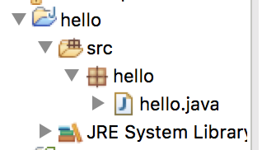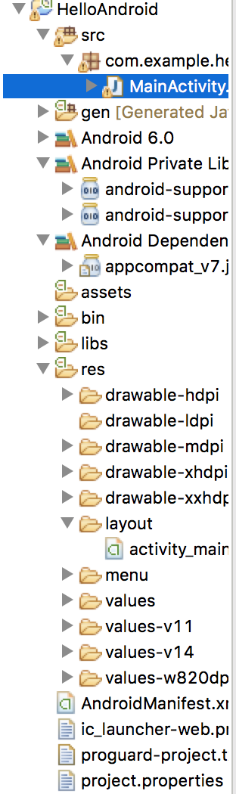

1. Different performance

The performance of desktop edition and android edition has numerous difference.

For example: User clicks mouse on the desktop and then gets the action. But in the phone, it would be replaced by touching. As experienced coder said, there are some obvious problems on exchanging method between “mouseClick” and “touch”.

In the “mouseClick”, generally it divides into three actions. Mousedown, click and mouseup are to perform functional steps. But for the “touch”, this only has touchstart and touchend. According to two methods test (Ye, 2013), the speed of mouseClick is much slower than touch. Even a second delay on the actions and this project has lots of calculation on engine, which already influences user’ experience, would decrease enthusiasm to some degree.

1. Different Content

Due to the space and functional difference, the content has to be changed.

For example: In the desktop version, we could list steps and functional results on the history list. On the phone, the screen does not have so much big space to show this and we would change it as real movements.

References:

Bodlaender, H. and Duniho, F. (2014), “Xiangqi: Chinese Chess” available at: <http://www.chessvariants.com/xiangqi.html> (accessed December 12, 2015)

Ye, X (2013), available at: <http://www.cnblogs.com/yexiaochai/p/3377900.html> (accessed December 12, 2015)